ESS - Attaching a Document QRG

Attaching a document within Employee Self Service (ESS).

1. Within the home page, click on View Profile.

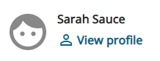

1. Within your profile, locate My personal details and click Edit.

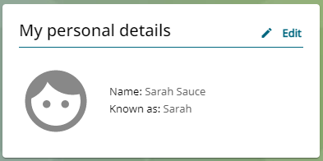

1. Within my personal details, scroll down the page and locate attachments.
2. Click on view attachments to add a new document.
3. Click on add attachments.



1. Within the document name box, enter the document title, for example - Change of Name.
2. Within the document type, select HR from within the drop-down list.
3. Click on the upload file.



1. You can either take a picture of your document by using your phone’s camera or you can upload from your files.

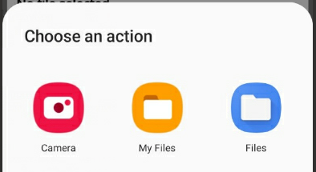

1. Click on the save button.
2. This will take you back to the attachments section.
3. You must click save again to attach the document.

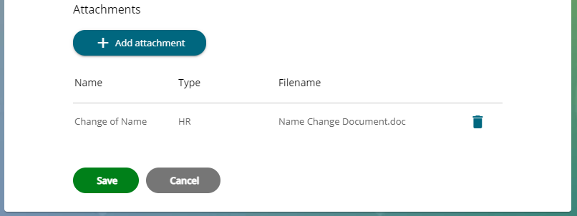

***Note -*** *If you do not click save for a second time, the attachment will not save.*

1. Once you have attached your document and clicked save twice, the following message will appear.



1. You can now see your attachment within your document attachment section.
2. When you click save, an email will be sent to Colleague Relations confirming that you have recently attached a document.

|  |  |  |  |
| --- | --- | --- | --- |
| Responsible (R) | Colleague Relations & Wellbeing | Accountable (A) | Human Resources |
| Consult (C) | Business Solutions | Inform (I) | All Business Units |
| Date | 18/08/2023 | Version | 1.0 |