ESS - Pregnancy Notification & Maternity Leave QRG

As soon as you inform your manager that you are pregnant, your manager will attach the following questionnaire forms to your Employee Self Service (ESS).

* Notification of Pregnancy Form (MP1)
* Annual Holiday Form (MP2)

Notification of Pregnancy Form (MP1)

1. Within ESS, click on your profile and select employment.
2. Within employment, scroll down and locate your Requests & Surveys.
3. Click on the new button.

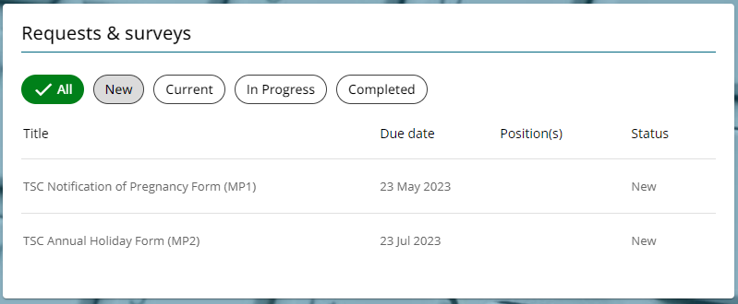

1. Click on the Notification of Pregnancy form (MP1).

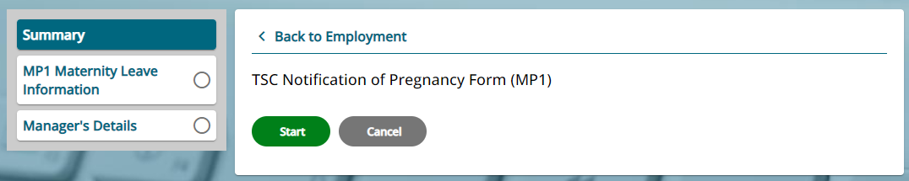

1. Click start and complete all the sections within the form.
2. Click save.

Your manager will complete the second part of the Notification of Pregnancy Form and will submit to payroll.

**Annual Holiday Form (MP2)**

1. Click on the Annual Holiday Leave Form (MP2).

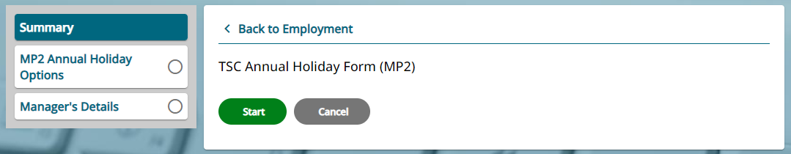

1. Click start and complete all the sections within the form.
2. Click save.
3. Following clarification of annual leave options within your MP2 form, you will need to submit your holiday requests following the holiday process.

The MP1 & MP2 forms will be acknowledged, and a copy of the Southern Co-op Family Friendly Guidebook will be attached within your Employee Self Service.

**Family Friendly Guidebook**

1. Within Employee Self Service, click on your profile and select personal.
2. Click on Edit within your personal details section.

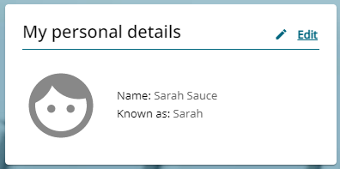

1. Scroll down the page and locate the attachment section.
2. Within attachments you can download, view, or print the Family Friendly Guidebook.

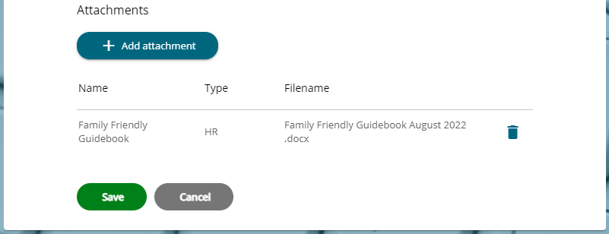

If you have any additional questions, please speak with your manager in the first instance.

You will receive further correspondence, confirming Statutory Maternity Pay entitlements.

**Antenatal Care**

Confirm all appointments with your manager, giving sufficient notice, where possible, so cover can be arranged.

For more information surrounding antenatal appointments, refer to your Family Friendly Guidebook.

**Providing your MATB1 Form**

This is the certificate you will receive from your doctor or midwife no earlier than 20 weeks before your baby is due. It confirms the expected week of childbirth (EWC).

1. Discuss and show your manager your MATB1 form and confirm any relevant details.

You will now need to attach a copy of your MATB1 form within your Employee Self Service. *Refer to WFM - Attaching a Document (ESS) QRG.*

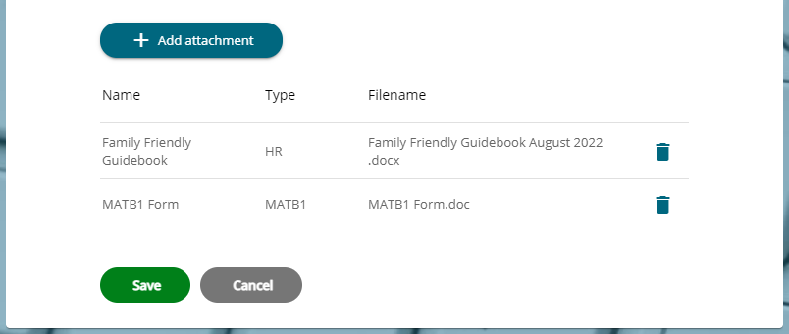

1. You will receive further correspondence regarding your MATB1 form.
2. If your circumstances change, please speak with your manager in the first instance.

**Maternity Leave – KIT Days**

Keeping-in-touch days (KIT days) – except during the first two weeks after the birth of the baby, you can, subject to the agreement of the Southern Co-op, undertake up to 10 days of keeping in touch days during your maternity leave. *Refer to Keeping In Touch & Shared Parental Leave In Touch Days Policy* and *ESS* - *How to claim for a KIT Day via Time & Expenses QRG.*

**Return to work**

|  |  |  |  |
| --- | --- | --- | --- |
| Responsible (R) | Colleague Relations & Wellbeing | Accountable (A) | Human Resources |
| Consult (C) | Business Solutions | Inform (I) | All Business Units |
| Date | 25/05/2023 | Version | 1.0 |

If you wish to return before your full entitlement of maternity leave (52 weeks) has elapsed, you must complete the Return to Work Following Maternity Leave Form, giving at least 8 weeks’ notice in writing to Southern Co-op of the date on which you intend to return. Legally, a colleague is not permitted to return to work unless she has taken at least 2 weeks maternity leave after the birth of the baby.