ESS - Resignation QRG

How to process your resignation within Employee Self-Service (ESS).

1. Within the home page, click on View Profile.
2. Within your profile, click on the Employment tab, which can be located on the top bar.



1. Click on your current position details, within My Employment.

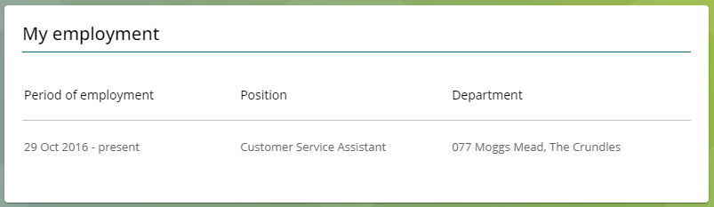

1. Scroll down the page until you locate the resignation notification section.
2. Enter the date, which will be your last working day, which should be inclusive of your notice period and any authorised holiday booked.
3. You will then need to write your resignation letter, within the resignation statement box available.
4. Once you have saved the detail, you can no longer amend, and the boxes will appear in grey.
5. When you are confident with the details recorded, click save.

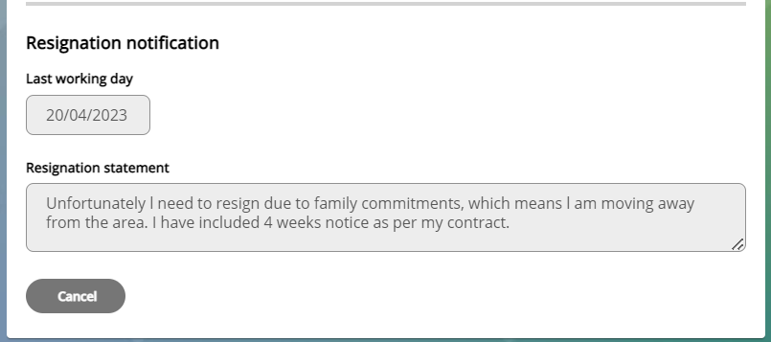

1. Your manager will receive an email confirming your intention to resignation.
2. Your manager will discuss your resignation with you, where they will explore alternative options for you to consider before continuing with your resignation.
3. If you decide to withdraw your resignation, this will be cancelled by your manager.
4. When the resignation has been cancelled, the details will be removed from the resignation notification section within your Employee Self Service.

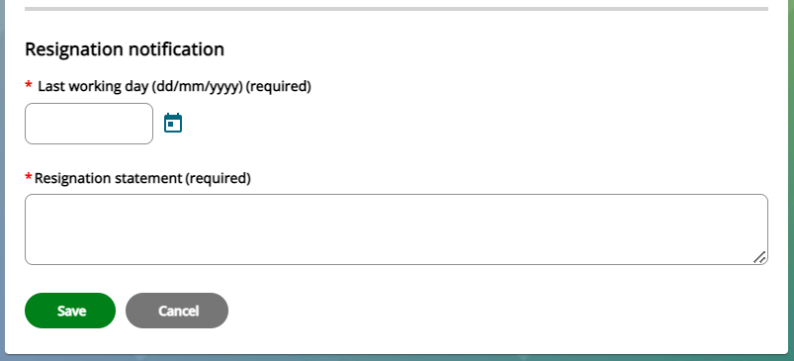

1. If the resignation still stands, there is no further action required by yourself.

|  |  |  |  |
| --- | --- | --- | --- |
| Responsible (R) | Colleague Relations & Wellbeing | Accountable (A) | Human Resources |
| Consult (C) | Business Solutions | Inform (I) | All Business Units |
| Date | 18/07/2023 | Version | 1.0 |